1-Composer
# Source: AI Source: Provided by: [Data Path: Persons Table -> ID Column: 1, Name_En Column: Motasem Essam] -> From: [Chatgpt (GPT‑5 Mini)] on [1/26/2026]
Composer is a dependency manager for PHP.
It helps PHP developers install, manage, and update libraries (also called packages) that a project depends on.

🧰 What Composer Does
# Source: AI Source: Provided by: [Data Path: Persons Table -> ID Column: 1, Name_En Column: Motasem Essam] -> From: [Chatgpt (GPT‑5 Mini)] on [1/26/2026]
- 📦 Installs PHP libraries your project needs
- 🔄 Updates them easily
- 🧩 Manages sub-dependencies (dependencies of dependencies)
- 📜 Uses a file (composer.json) to keep track of everything

📌 Example Use Case
# Source: AI Source: Provided by: [Data Path: Persons Table -> ID Column: 1, Name_En Column: Motasem Essam] -> From: [Chatgpt (GPT‑5 Mini)] on [1/26/2026]
Let’s say you're building a PHP project that needs a library like Monolog (for logging):
1. You create a file called composer.json that says:
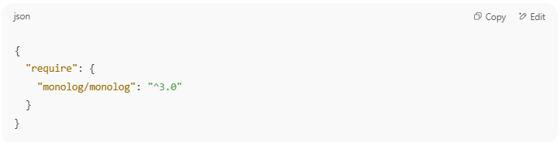
{
"require": {
"monolog/monolog": "^3.0"
}
}

2. You run:
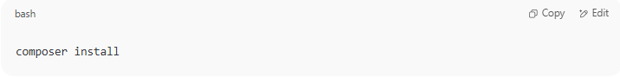
composer install

3. Composer:
  - Downloads Monolog and its required dependencies
  - Puts them in a vendor/ folder
  - Creates a composer.lock file to lock versions

✅ Common Composer Commands
# Source: AI Source: Provided by: [Data Path: Persons Table -> ID Column: 1, Name_En Column: Motasem Essam] -> From: [Chatgpt (GPT‑5 Mini)] on [1/26/2026]

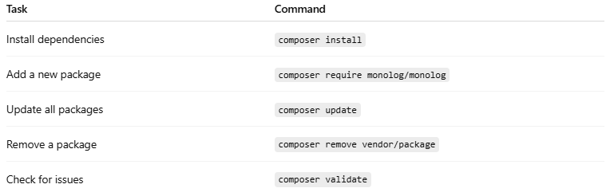

Task | Command
Install dependencies | composer install
Add a new package | composer require monolog/monolog
Update all packages | composer update
Remove a package | composer remove vendor/package
Check for issues | composer validate

📁 Typical Files Composer Uses
# Source: AI Source: Provided by: [Data Path: Persons Table -> ID Column: 1, Name_En Column: Motasem Essam] -> From: [Chatgpt (GPT‑5 Mini)] on [1/26/2026]
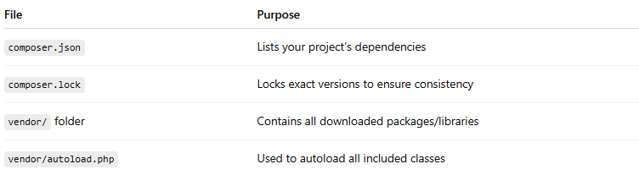

File | Purpose
composer.json | Lists your project’s dependencies
composer.lock | Locks exact versions to ensure consistency
vendor/ folder | Contains all downloaded packages/libraries
vendor/autoload.php | Used to autoload all included classes
You can include this in your PHP:
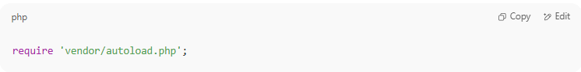
require 'vendor/autoload.php';

🧠 Why Use Composer?
# Source: AI Source: Provided by: [Data Path: Persons Table -> ID Column: 1, Name_En Column: Motasem Essam] -> From: [Chatgpt (GPT‑5 Mini)] on [1/26/2026]
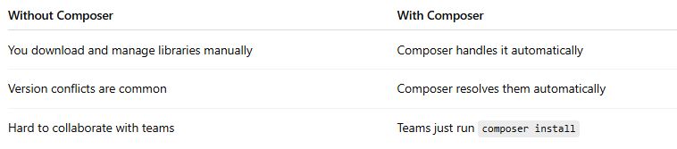

Without Composer | With Composer
You download and manage libraries manually | Composer handles it automatically
Version conflicts are common | Composer resolves them automatically
Hard to collaborate with teams | Teams just run composer install

🧪 Example in Real PHP App
# Source: AI Source: Provided by: [Data Path: Persons Table -> ID Column: 1, Name_En Column: Motasem Essam] -> From: [Chatgpt (GPT‑5 Mini)] on [1/26/2026]
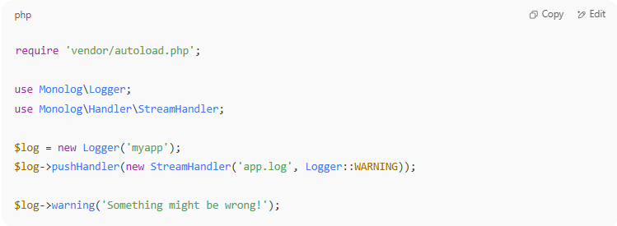

require 'vendor/autoload.php';

use Monolog\Logger;
use Monolog\Handler\StreamHandler;

$log = new Logger('myapp');
$log->pushHandler(new StreamHandler('app.log', Logger::WARNING));

$log->warning('Something might be wrong!');

Download Composer
# Source: AI Source: Provided by: [Data Path: Persons Table -> ID Column: 1, Name_En Column: Motasem Essam] -> From: [Chatgpt (GPT‑5 Mini)] on [1/26/2026]
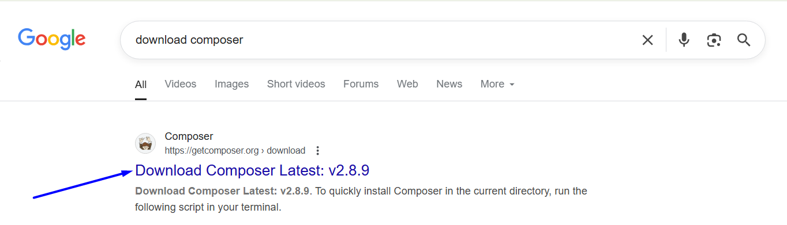

https://getcomposer.org/download/
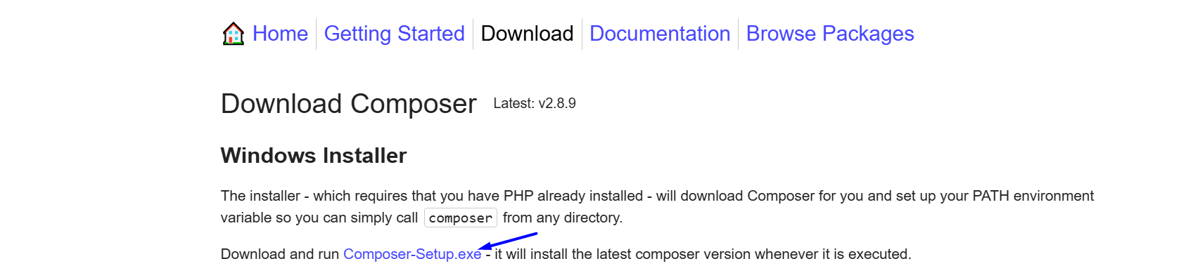

Install Composer
# Source: AI Source: Provided by: [Data Path: Persons Table -> ID Column: 1, Name_En Column: Motasem Essam] -> From: [Chatgpt (GPT‑5 Mini)] on [1/26/2026]
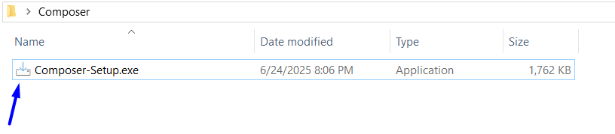
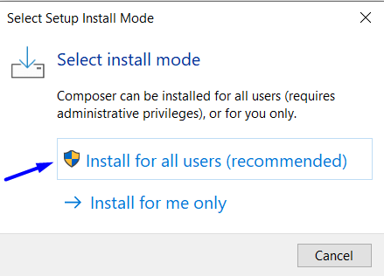
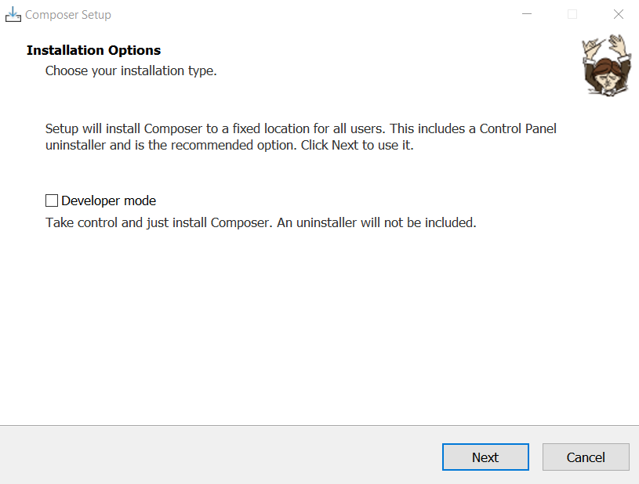
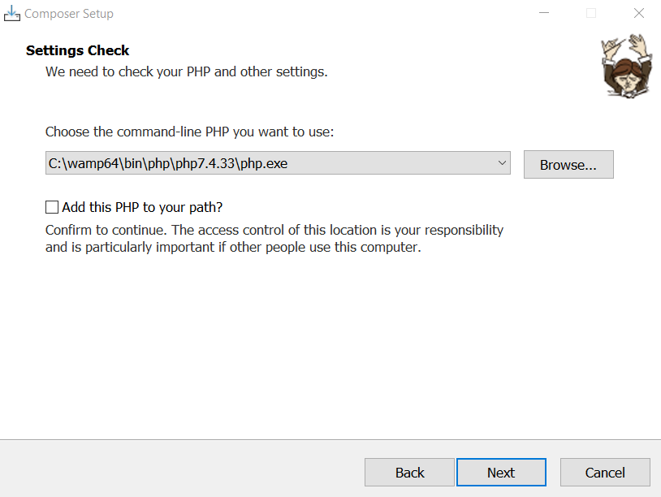
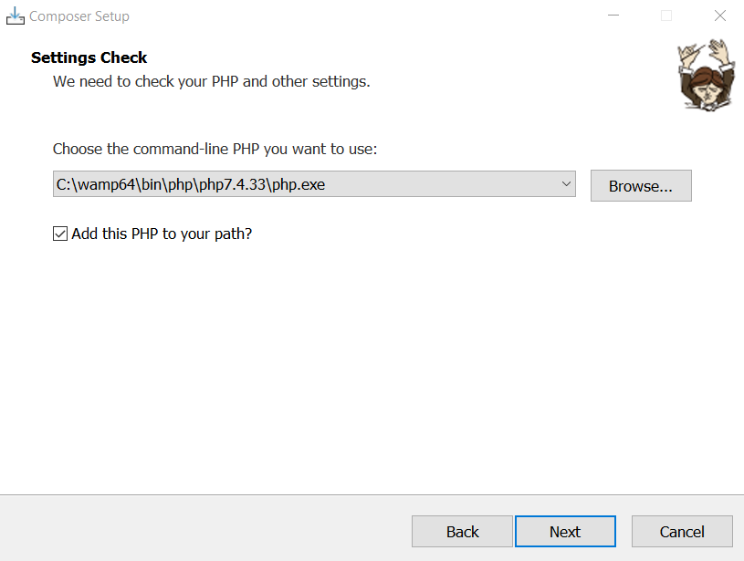
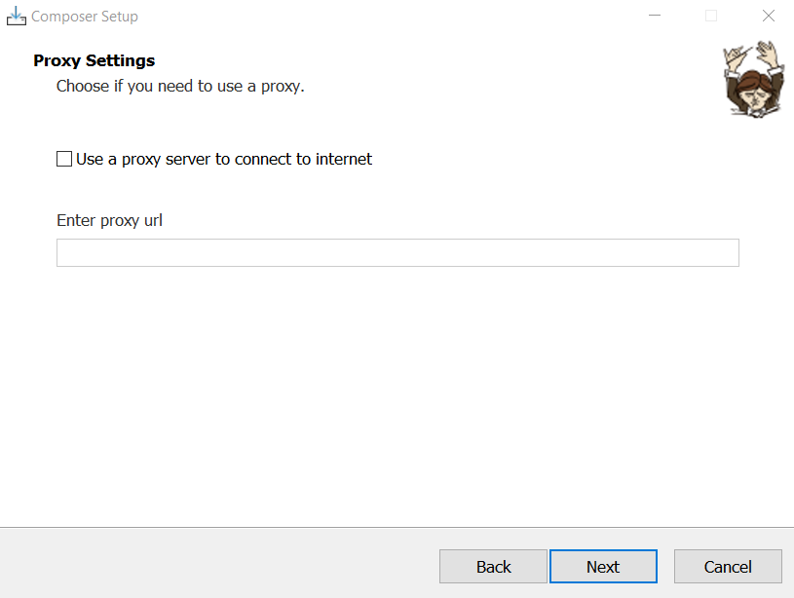
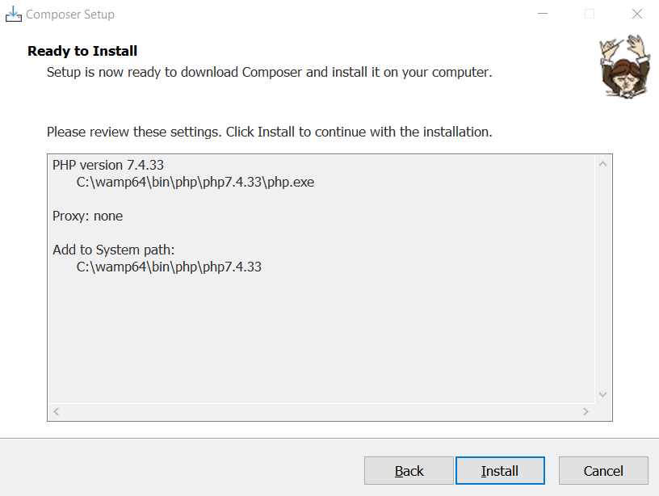
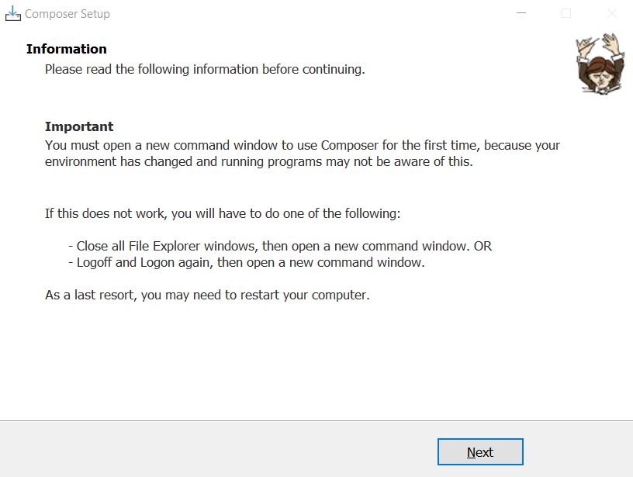
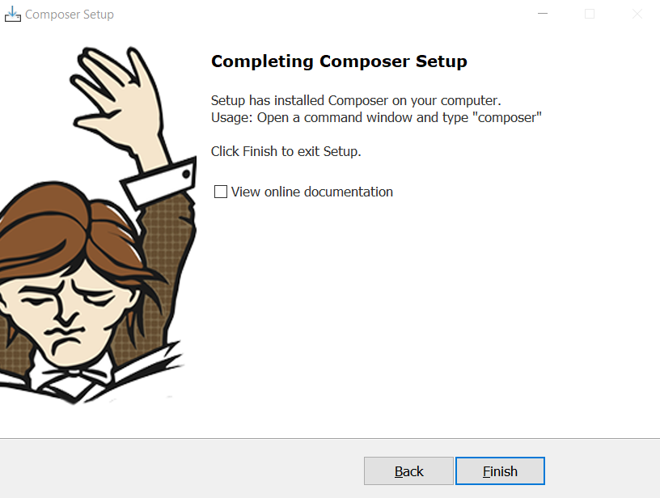

Run Composer
# Source: AI Source: Provided by: [Data Path: Persons Table -> ID Column: 1, Name_En Column: Motasem Essam] -> From: [Chatgpt (GPT‑5 Mini)] on [1/26/2026]
C:\wamp64\bin\php\php7.4.33

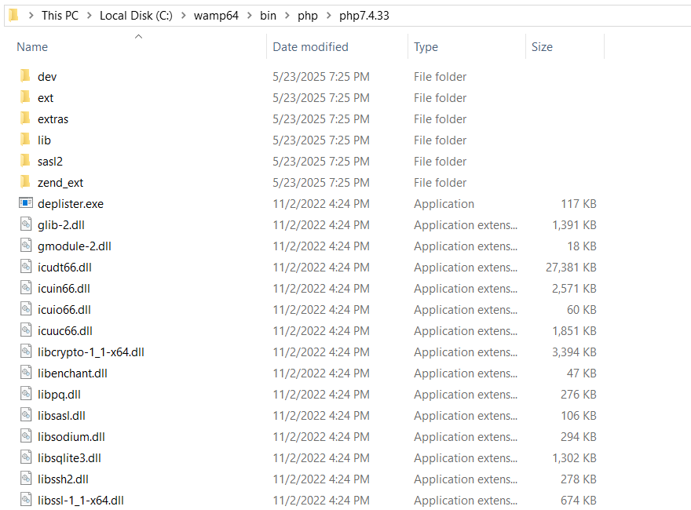
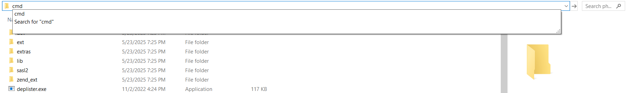
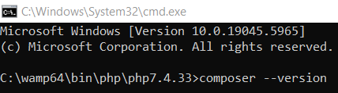
composer --version
